Type of Events/Alerts:

Below is the list of the system alerts that you will be receiving a notification for in case if they are triggered. Most of the alerts are configured to send a notification to the previously defined the 3 levels of alert contacts.
- Temperature: Temperature events are triggered when an asset's temperature report meets the defined conditions.
There are 3 levels of the temperature alerts based on time (Temp out of Range - 15 Minutes, Temp out of Range - 30 Minutes, and Temp out of Range - 45 Minutes).

- Asset Properties: Asset Properties events are triggered when a custom property or status of an asset stays for a certain time.

The main purpose of this event is to stop the temperature alert from escalation when acknowledged by changing the sensor’s properties (status).

Please note: This event works together with the Temperature Alert and will not be sending notifications to users. There are 2 types of asset properties alerts, and they are as below:

- Asset Properties – Manual: If the temperature alert being triggered and acknowledged, this alert will be triggered, and it can be seen as a pending alert in the alert page for the web application. Please DO NOT acknowledge (dismiss) this alert until you fix the issue with the freezer that caused the temperature to be out of range, because it will reset the sensor’s properties (status) back to normal when acknowledged. If this issue with the freezer did not get fixed (this alert is not acknowledged for 3 hours), another alert will set the sensor status back to normal automatically. And this alert called “Asset Properties – Automatic”.
- Asset Properties – Automatic: This event will not be shown as a pending alert in the app, and it will acknowledge itself in 3 hours and change the sensor status back to normal automatically. This evet will act as a backup if someone forgets to acknowledge the Asset Properties – Manual if the freezer issue has been fixed within 3 hours, and if not, it will reset the status to receive a new temperature alert.

Temp Alert Flowchart:

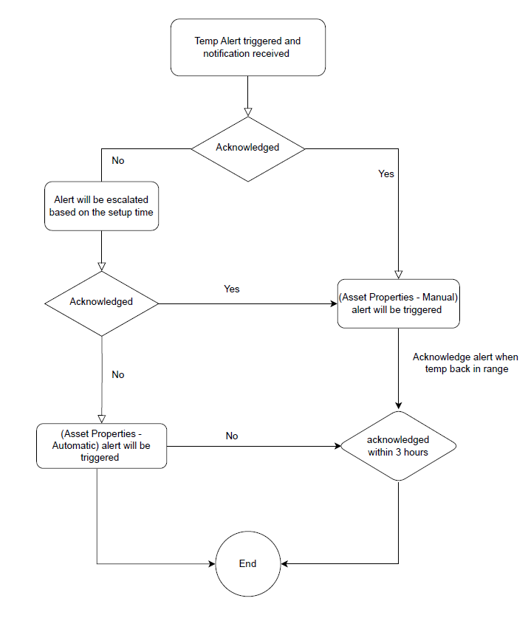

- Sensor Monitor (Door Alert): Sensor events are triggered when an asset's sensor measurement report meets the defined conditions.
There is only one level of the door alert (Door Open - 5 Minutes). This alert will send notifications to the first contact group only. This event has a reminder every 5 minutes until the door is closed.

- Sensor Tag Error: Sensor tag error events are triggered when an error occurs on the sensor tag which prevents receiving data. Example of sensor tag errors are probe disconnection, probe malfunction, etc.
There are 3 levels of the sensor tag error alerts based on time (Sensor Tag Error - 15 Minutes, Sensor Tag Error - 30 Minutes, and Sensor Tag Error - 45 Minutes).

- Out of Sight: Out of Sight event monitors are triggered when new location reports stop being received. This alert helps to capture any Wi-Fi connectivity issues.
There are 2 levels of the out of sight alerts based on time (Out of Sight - 1 Hours and Out of Sight - 2 Hours).

- External Power: External power events are triggered upon power disconnection from tags which support external power and meets the defined condition.
There are 3 levels of the external power alerts based on time (AC Power Loss - 5 Minute, AC Power Loss - 15 Minute, and AC Power Loss - 30 Minute).

- Battery Level: Battery Level events are triggered when a tag's battery level reaches a specified threshold.
There is only one battery alert based on battery level (Battery Low - 10%). This alert will send notifications to the first contact group only. This event has a reminder every 24 hours until the battery being replaced.

- Temperature: Temperature events are triggered when an asset's temperature report meets the defined conditions.
- Asset Properties: Asset Properties events are triggered when a custom property or status of an asset stays for a certain time.
- Sensor Monitor (Door Alert): Sensor events are triggered when an asset's sensor measurement report meets the defined conditions.
- Sensor Tag Error: Sensor tag error events are triggered when an error occurs on the sensor tag which prevents receiving data. Example of sensor tag errors are probe disconnection, probe malfunction, etc.
- Out of Sight: Out of Sight event monitors are triggered when new location reports stop being received. This alert helps to capture any Wi-Fi connectivity issues.
- External Power: External power events are triggered upon power disconnection from tags which support external power and meets the defined condition.
- Battery Level: Battery Level events are triggered when a tag's battery level reaches a specified threshold.

